Coastal

Limble Integration Review Document: EHS Integration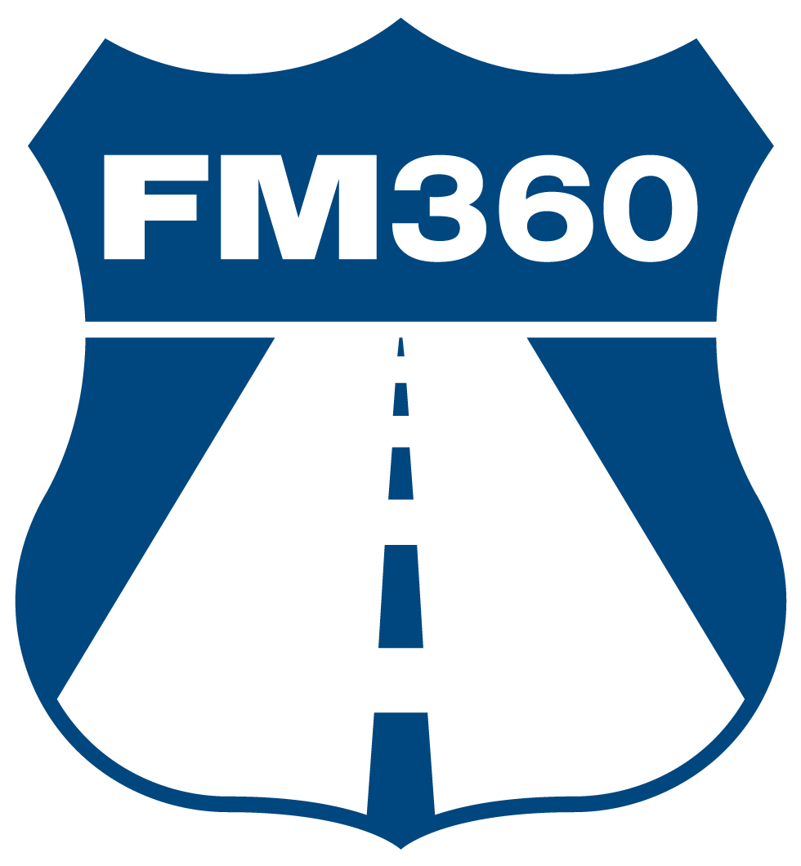
V1.3.2
April 8th, 2025
Table of Contents
Authors/Contacts: 3
Revision History: 3
Overview: 3
Expectations: 4
Final Integration: 4
EHS Integration: 4
Creating WO Integration: 4
Updating EHS Inspection Integration: 5
Limble Template: 6

Authors/Contacts:
Name | Initials | Email
Ethan Morris | EM | ethan@fm360consulting.com

Revision History:
Version Number | Version Date | Changes/Updates | Edited By
1.0.0 | 11/11/2024 | Initial Draft | EM
1.1.0 | 1/22/2025 | Updated the EHS subsection for the Expectations section as well as the EHS Integration section | EM
1.2.0 | 1/24/2025 | Update the EHS Integration section to add the portion of sending Limble WO completion notes back to EHS inspection and updating the Limble template section | EM
1.3.0 | 1/27/2025 | Minor edits to the Limble Template section, and the Coupa Integration parts removed as they will be on a different review document | EM
1.3.1 | 3/11/2025 | Updating EHS integration and template sections to reflect latest updates. | EM
1.3.2 | 4/8/2025 | Final updates before Go-Live | EM

Overview:
Coastal requested FM360 to develop two integrations: one between EHS Insight and Limble and the other between Limble and Coupa. This document serves as a record of the expectations and the implementation of the EHS side of the integration project.

Expectations:
Per the signed project proposal, the expectations for this integration project are as follows:
- EHS Integration
  - There is an SOP completed in EHS called “Facility Inspection Checklist”. The last question in this SOP asks if any of the deficiencies from the other items in the SOP require a WO to be created. If so, then an integration needs to be utilized to create those WOs in Limble.
  - This integration will be time-based and will run daily at 6PM (EST).
  - The integration will look at SOPs that have been completed since the last integration run (i.e. the last 24 hours).
    - NOTE: it is assumed that the SOP will not be performed more than once a day per location (called “Business Entity” in EHS).
  - The integration will also be able to push completion notes from SOP-related Limble WOs back to their corresponding SOP records in EHS to notify that these items have been remedied.

Final Integration:

EHS Integration:

Creating WO Integration:
This integration will capture the last question of the “Facility Inspection Checklist” SOP and create a Limble work order if that last item is selected as “Not Acceptable”. Below are the specifications for the integration:
- This integration will be carried out every day at 6PM (EST).
- In order to grab the “Facility Inspection Checklist” SOPs that were performed that day, when grabbing the SOP records from EHS, the integration will filter to include only SOPs that have a “DatePerformed” datetime of the past 24 hours AND have “Facility Inspection Checklist” as the Question Set.
  - The integration will also check a record’s “RecurringTaskCompleteDtm” field to ensure that only those SOPs that have been submitted are grabbed (i.e. no drafts of an SOP)
- Though it is assumed that this SOP will not be conducted more than once a day (per location), there are two catches in place:
  - 1. If there is more than one SOP in a given day but they were conducted at different sites (called “Business Entity” in EHS), then the integration will process each one.
  - 2. If there is more than one SOP in a given day for the SAME site, then the integration will look at the UpdateDtm field (i.e. when the SOPs were last updated) and use the SOP that was most recently updated.
- After filtering through the grabbed SOPs, the integration will then iterate the process below for each SOP remaining:
  - The integration will evaluate the last question item (the section called “Deficiency Summary and Work Order Creation”) to see if this item has “Not Acceptable” selected
  - If “Not Acceptable” is selected the integration will grab the list of deficiencies typed in the question’s text box and then create a WO in Limble.
    - See the “Limble Template” subsection below for how the EHS WOs are structured.
    - The Limble WO will use the selected Business Entity of the inspection form to determine which Limble location to create the WO in.
      - In addition, the Limble location will also dictate the default assignee for the WO.
        - A team is created in each Limble location called “EHS Assignees” and the integration will point to the instance of this team that belongs to the Limble location the WO is being created in.
  - In addition to creating the WO, if there is an image file-type attachment associated with the “Deficiency Summary and Work Order Creation” question item, then after creating the WO, the integration will update the “Work that Needs to be Done (from the EHS Inspection)” instruction include that attachment.

Updating EHS Inspection Integration:
Once an EHS-related Limble WO is completed, there was a need to generate a notification back to the EHS inspection that those unacceptable items have been remedied. To perform this action, a 2nd EHS/Limble integration was created. Below are its specifications:
- This integration operates on an event-based schedule
  - The integration will trigger upon a Limble WO being completed.
    - To verify that it is an EHS-related WO that is being processed, the integration looks to see if the WO contains the “@EHSWO;” tag.
  - The integration will grab the details of the WO – including the hidden meta1 field (which contains the EHS inspection ID), the completion date, and the completion notes (if written) – to prepare the data that will be sent back to the EHS inspection.
    - The completion notes sent back to EHS will be the completion notes typed in the EHS WO as well as the completion notes of all of its child WOs.
  - A completion packet is created and formatted to show the following in EHS:
“(Completed <Limble WO’s Completion Date>)
All discrepancies listed in the last question have been remedied. Here are the completion notes from Limble:
<Completion Notes Grabbed from Limble>”
  - Using the saved EHS inspection ID, the integration pulls the inspection record from EHS, updates a custom field (see bullet point below) with the completion packet, and then POSTs the record back to EHS so that the completion packet now shows in that custom field.
    - NOTE: A new text box field called “Limble WO Completion Notes” has been created for the Audit Inspection Forms. This box will house the completion packet that is sent from Limble.

Limble Template:
All EHS WOs in Limble will follow the Coupa process for remedying the inspection discrepancies; however, given that it is likely that WOs created from EHS inspections will contain more than 1 deficiency, the client wanted a WO created for each deficiency. Thus, the EHS inspection will create a single WO to serve as a parent WO from which child WOs can be created for each discrepancy listed in the “Work that Needs to be Done (from the EHS Inspection)” instruction. Below is the default structure of this parent WO template:
- The name of the WO will be EHS WO Template - <the inspection form number added by the integration>
- The description field of the WO will be populated with the site where the inspection took place (along with the “@EHSWO;” tag).
- The template will have 3 default instructions in place:
  - The first is a label-type that simply lists out the deficiencies that the inspector typed from EHS (along with any image attachments they attached to that last question in the inspection form)
  - The second is an instruction to generate a child WO. It contains a button that, when clicked, will open up a new WO window wherein the child WO can be created.
    - This instruction will preload the new WO with the template that follows the Coupa workflow (the template is called “Main WO Template (Limble-to-Coupa)”).
    - The default assignee for these child WOs will be the one assigned to the main EHS WO.
    - If there is more than 1 deficiency that needs a WO, after creating the previous WO, the button to generate a child WO will remain and can be used again to generate more.
  - The last instruction is a checkbox-type that is used to help assignees ensure that all child WOs have been completed before proceeding to complete the main WO.
- The default priority is 3 (i.e. low priority). This can be changed in the WO by those who have permission to edit WO priorities.
- This parent WO will also serve as the WO that handles communication back to EHS.
  - Thus, only when this WO is complete will the 2nd integration grab the completion information and send it back to the EHS inspection form.
- The due date is defaulted to the day of its creation date. This can be updated by those who have permission to edit WOs.
- The default assignee will be determined in the integration using the location selected in the EHS inspection form.

